Introducing Med App
We are excited to introduce Med App, a digital handbook that will help you in your daily activities at the hospital. Designed to be a quick reference tool for accessing clinical and hospital guidelines & receiving important hospital communication.
- Overview & features
- Phone directory - bypass switch, call direct
- Finding guides & content?
- Bookmarking favourite content and hospital numbers
- Export proof of CPD & attendance from your phone
- Rotating and changing hospitals
- Provide feedback & suggestions on the resources you need
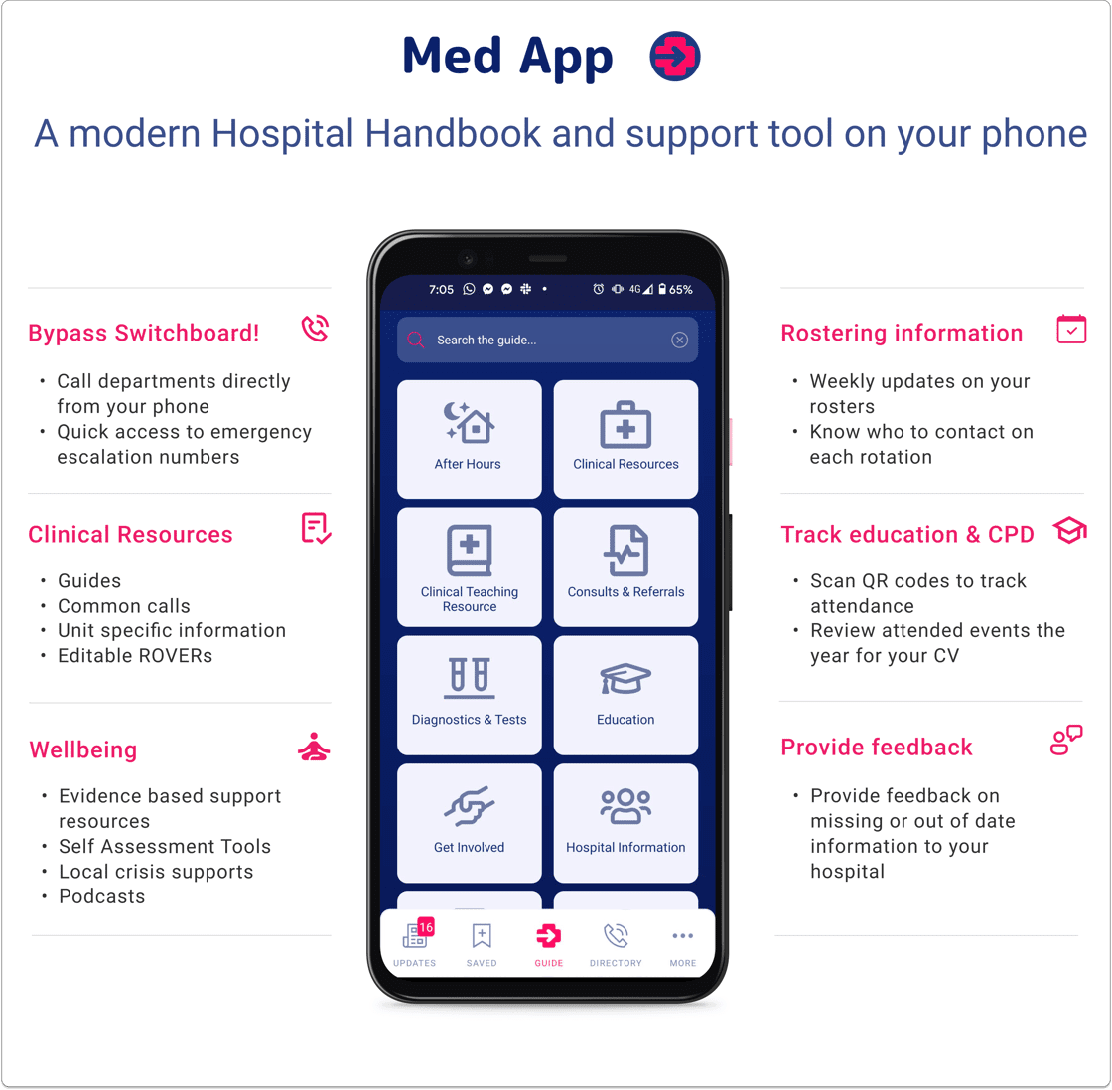

How do I join Med App?
We will send you an SMS invite shortly prompting you to take the following steps.

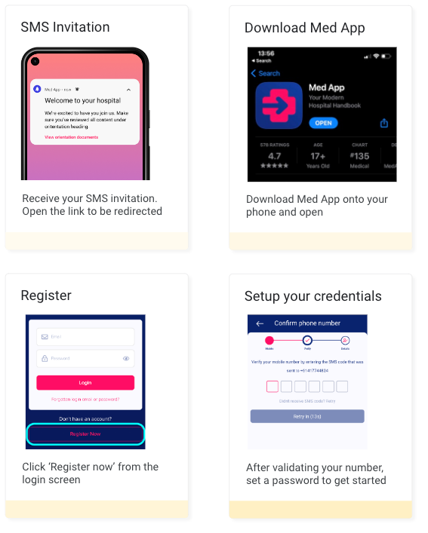

A short teaser
Watch the video below to see a short preview.

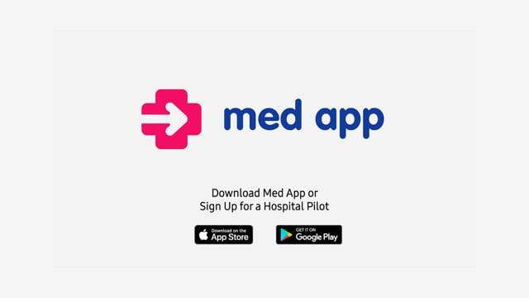

We take your privacy seriously
To learn more about our policy click here

Have questions? Either respond to this email or contact the sender on support@medapps.com.au

